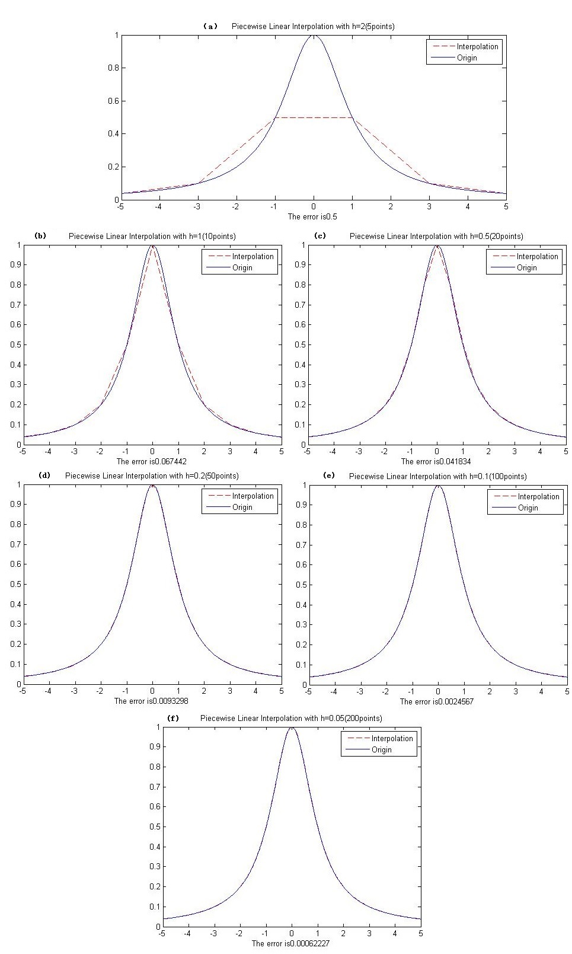
Figure 5.1 Piecewise Linear Interpolation with (a) h=2; (b) h=1; (c)h=0.5 (d) h=0.2; (e)h=0.1; (f) h=0.05
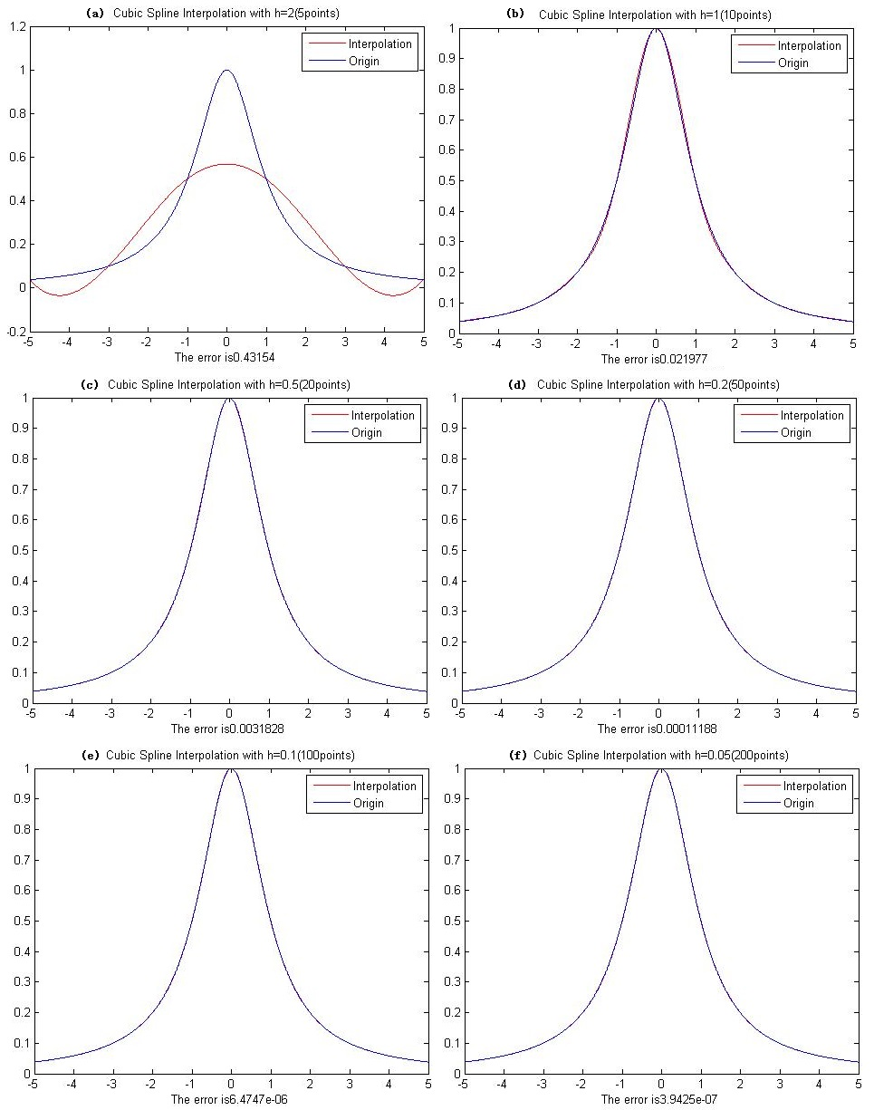
Figure 5.2 Piecewise Cubic Spline Interpolation with (a) h=2; (b) h=1; (c)h=0.5 (d) h=0.2; (e)h=0.1; (f) h=0.05

